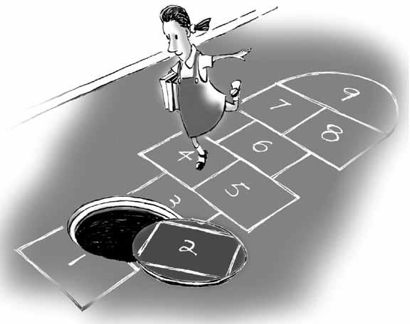
HOPSCOTCH HAMLET
Game Design Adventure #1
Due via email of a PDF to gamedesign-pgh-support@lists.andrew.cmu.edu,
Named firstname-lastname-hopscotch.pdf before 1:00pm, Tuesday, January 23

The goal of this assignment is to create an improved version of the game of Hopscotch. Document your process as you go. Your work will be judged on how enjoyable a game you manage to create – for the intended audience.

Part I
- List some of the things that make hopscotch a good game.
- List problems with the game of hopscotch that your design might try to solve.
- Brainstorm (in writing) at least fifty ideas about hopscotch. You might also find it useful to brainstorm in four categories: Technology, Story, and Game Mechanics, and Aesthetics.
Part II
Based on some of your ideas in Part I, come up with at least three ideas for new versions of Hopscotch, and describe them in writing. Choose what you really feel are the most promising candidates for a fun, successful game – not impossible things you could never really play.

Part III
Take at least one of your ideas from Part II, and:
- Come up with a complete rule set.
- Try playing it – detail who plays, and what happens during the playtest.
- Analyze (in writing) what is good and bad about it.
- Make improvements based upon your analysis, and playtest it again, at least once.
- Analyze (in writing) the “improved” version or versions.
- Did your game solve the problems you described? Why or why not?

How we will grade:
- Problem statement: 10%
- Brainstorming: 10%
- Your three ideas: 10%
- Rules description: 10%
- Game playtesting and analysis: 30%
- Does the game solve the problem? 10%
- Does the game seem fun? 20%

